

**AUTHOR of CHANGE**

**Transformational Coaching Program**

Step 3

***Author of a Change-Inspiring Book***

➢ **How to Traditionally Publish Your Book**

➢ **How to Self-Publish Your Book**

with

Nina Amir and Deborah Levine Herman

**How to Get Your Book Traditionally**



**Published**

➢ A traditional publisher serves as a venture capital partner

➢ This is where your evaluation comes into play.

➢ Unique and necessary idea?

➢ Big market or niche market?

➢ Strong platform and promotion plan?

➢ You need to be a good publishing partner

➢ Evaluate your readiness: Are you a good candidate?

Why Seek a



Traditional Publisher

➢ You don’t want to be a

“project manager.”

➢ You don’t want to invest

your own money in your project.

➢ You want broader distribution for your book.

➢ You want credibility or authority in your field.

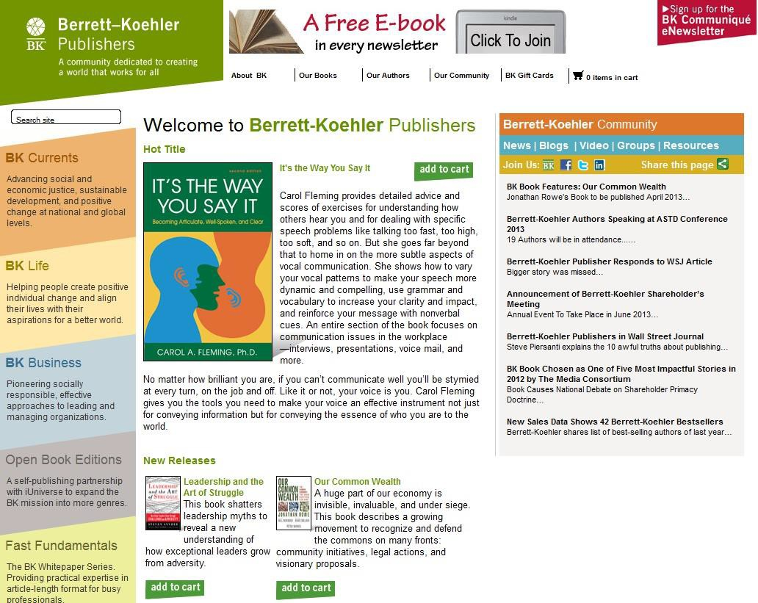

Types of Traditional Publishers

➢ Independent Publishers

➢ Small

➢ More personal

➢ More accessible

➢ May not require an agent

➢ Hampton Roads

➢ New World Library

➢ Berrett-Koehler

➢ Red Wheel/ Weiser/Conari

➢ Hay House

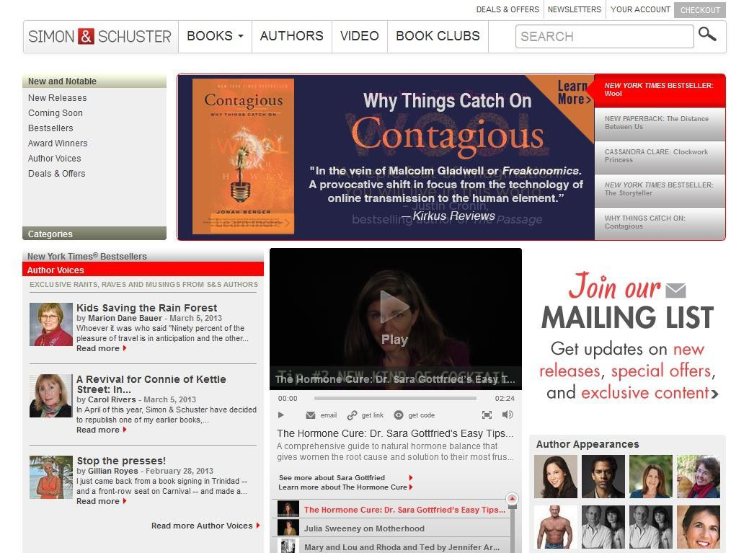

Types of Traditional Publishers

➢ Large and Mid-Sized Houses

➢ More risk adverse

➢ Higher standards

➢ More emphasis on

platform

➢ Must have an agent

➢ Random House

➢ Simon & Schuster

How Does a Book Get Sold



to a Traditional Publisher?

➢ What is a literary agent?

➢ Door opener

➢ Creative consultant

➢ Contract negotiator

➢ What is an acquisitions editor?

➢ Publisher’s representative

➢ Creative consultant

➢ Advocate for a book

➢ What is a Pub Board, Editorial or Marketing Meeting?

➢ Where your book idea (proposal) gets discussed



Why You Need an Agent

➢ Agents:

1. Provide publishing contacts

2. Pitch to appropriate publishers

3. Negotiate contract terms

4. May help with book proposal development

5. Offer career planning

Queries & Proposals Sell



Books to Agents & Publishers

➢ What goes into a query

➢ Why you, why this book, why now.

➢ Compelling lead paragraph with pitch

➢ Paragraph describing the benefits of the book

➢ Paragraph on why you are the best person to write the book.



What Goes into a Nonfiction Proposal?

➢ **Introduction**

➢ Overview

➢ *Markets*

➢ *Spin-offs*

➢ *Promotion*

➢ *Competing Titles*

➢ *Complementary Titles*

➢ *About the Author*

➢ *Mission Statement*

➢ *Author’s Platform*



What Goes into a Proposal?

➢ **Outline**

➢ *List of Chapters*

➢ *Chapter Summaries*

➢ *Sample Chapters*

➢ **What’s the difference**

**in a fiction proposal?**

The Traditional



Publishing Process

➢ Submit query to an agent.

➢ Submit proposal (or manuscript

+ proposal) to agent if requested.

➢ Agent pitch to acquisitions editors.

➢ Agent submits proposal to editors.

➢ Contract negotiations.

➢ You write the book on deadline.

➢ \**Difference with fiction*



**How to Self-Publish Your Book**

➢ You back your own project and become a project manager—a publisher

➢ This is where your evaluation comes into play.

➢ Unique and necessary idea?

➢ Big market or niche market?

➢ Strong platform and promotion plan?

➢ You need to be a good businessperson.

➢ YOU are the publisher.

Why Choose



Self-Publishing

➢ You want to be a “project

manager”—an indie

publisher.

➢ Manage editors, designers, accounts at printers.

➢ You want to invest your money in your project.

➢ You want more control of your work.

➢ You want to earn more money per book.



Types of Self-Publishing Companies

➢ Offset Printing

➢ You hire all the subcontractors

➢ Imprint of your own

➢ You purchase large

quantities of books

➢ True self-publishing

➢ DIY



Types of Self-Publishing Companies

➢ Subsidy Presses

➢ Provide a variety of services

(editing, design, promotion)

➢ Could provide offset printing,

POD and/or Ebook

➢ No imprint of your own

➢ Lulu

➢ Author House

➢ Balboa Press

➢ Morgan James

Types of Self-Publishing



Companies

➢ Print on Demand

➢ One book printed per order

➢ Lightening Source

➢ CreateSpace

➢ Print books in stores with Espresso Book Machine



Types of Self-Publishing Companies

➢ Digital presses

➢ Great option for short runs, back-of-the-room sales or if you want control of distribution

➢ Fast, high-quality printing

➢ Small quantities

➢ No distribution

➢ 360Digital.com

➢ 48hourbooks.com

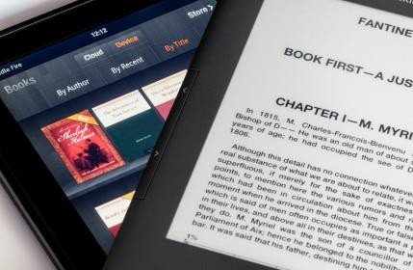

Types of Self-Publishing Companies

➢ Ebook publishing

➢ Different services and distribution offered by each company

➢ Offthebookshelf.com

➢ Bookbaby.com

➢ Kindle.com

➢ Smashwords.com



The Self-Publishing Process (P-Book)

➢ Evaluate your book.

➢ Have your manuscript professionally edited.

➢ Have a cover professionally designed.

➢ Have your interior professionally designed.

➢ Create account with a printer.

➢ Purchase ISBN

➢ Upload artwork.



The Self-Publishing Process (E-Book)

➢ Evaluate your book.

➢ Have your manuscript professionally edited.

➢ Have a cover professionally designed.

➢ Have your manuscript converted.

➢ Create account with ebook distributor.

➢ Purchase ISBN

➢ Upload cover and manuscript.

You Are Ready to Be



Authors of Change!

➢ Fulfill your purpose

➢ Follow your passion

➢ Become a magnet for likeminded souls

➢ Write a good book

➢ Reach your audience

➢ Inspire change in the world.

***Author the change you wish to see in the world.***



Important Information

➢ Facebook Page

➢ [www.facebook.com/groups/ACTCoachingProgram/](http://www.facebook.com/groups/ACTCoachingProgram/)

➢ Nina’s Email

➢ [namir@copywrightcommunications.com](mailto:namir@copywrightcommunications.com)

➢ Deb’s Email

➢ [deborah@waenet.com](mailto:deborah@waenet.com)

➢ Hand in all homework by April 5th for feedback

➢ Premier Students: Schedule your consults by April 12th

➢ Premier Students: Platform teleseminar and workbook will be posted within the week.